Plot 4 - The Furnival
£300,000.00

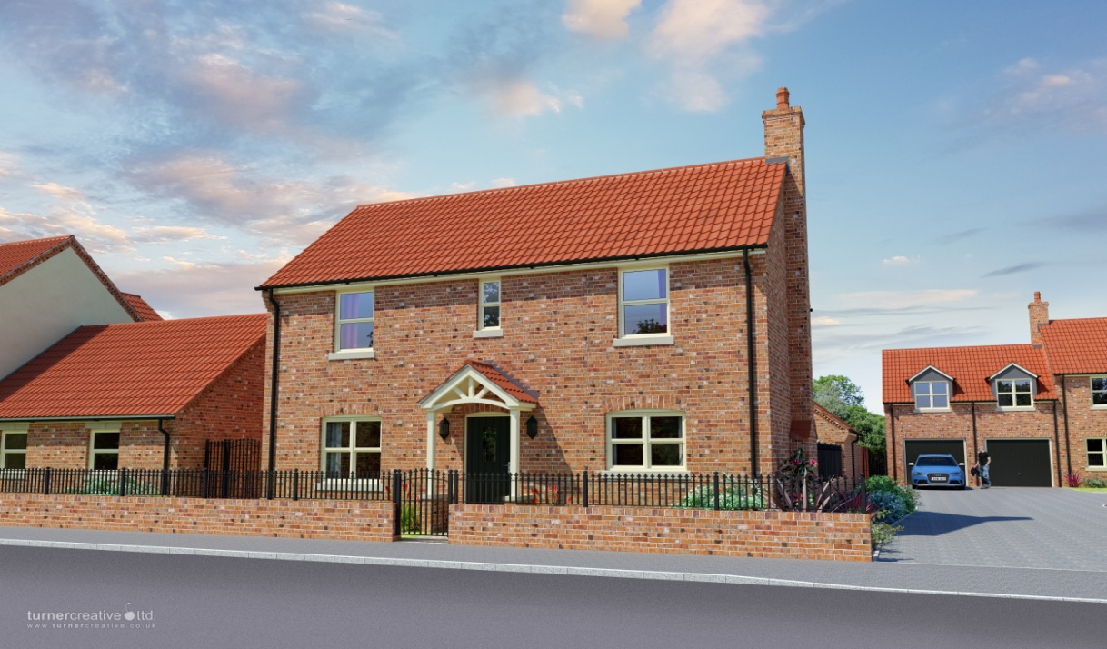

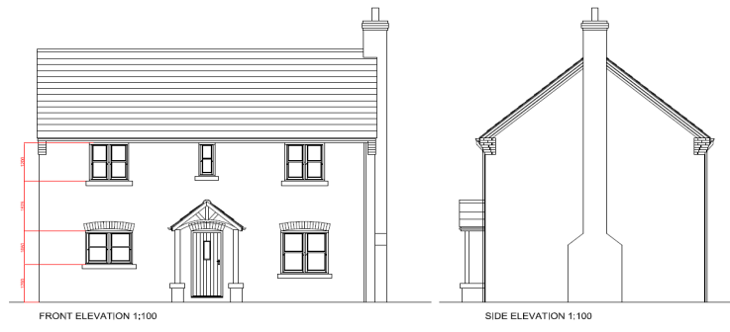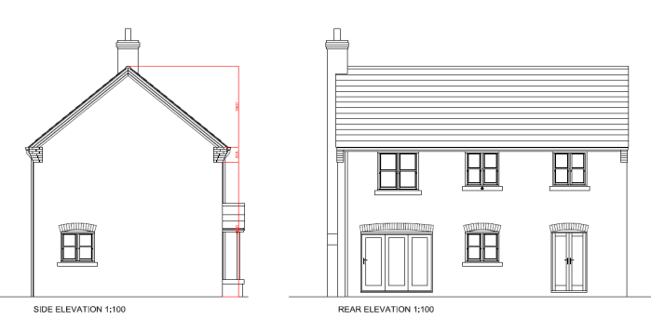
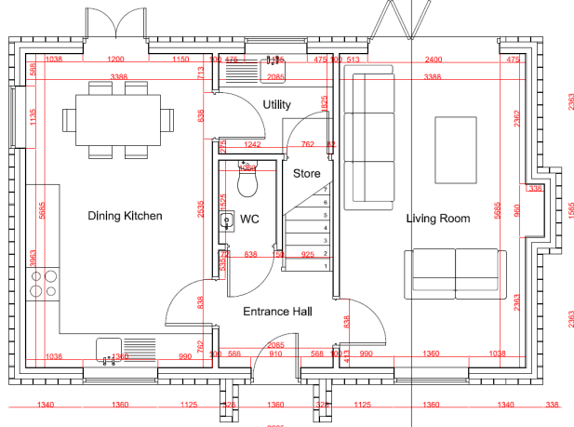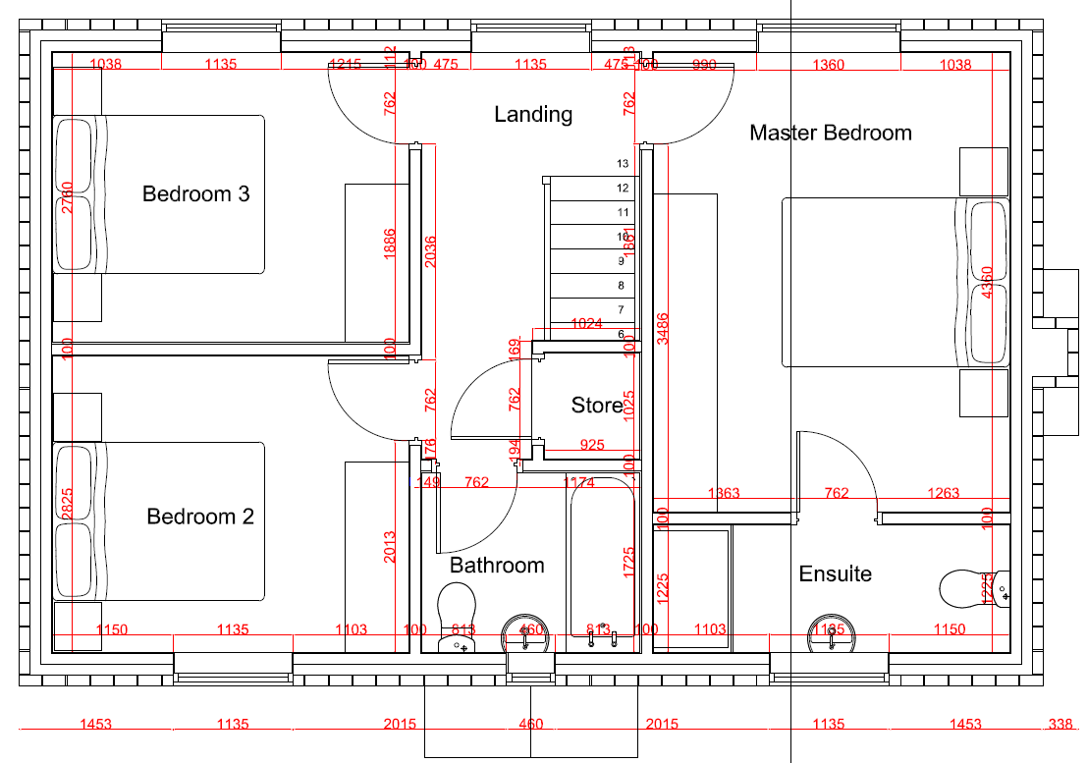

A development of 6 bespoke Architect designed luxury executive dwellings in the beautiful village setting of Walkeringham. A beautiful 3 bedroom detached house with a single detached garage and private rear garden. To the first floor of the property it comprises of 3 spaces bedroom with the master bedroom being en-suite with large family bathroom and separate storage room. To the ground floor the property comprises of entrance hall, kitchen-diner, utility, large living room and downstairs WC.

Ground Floor Measurements: First Floor Measurements:

Living Room - 5685mm x 3388mm Master Bedroom/En-suite - 5685mm x 3388mm
Entrance Hall - 2085mm x 1786mm Bedroom 2 - 3388mm x 2825mm
WC - 1525mm x 1060mm Bathroom - 2085mm x 1725mm
Utility - 2085mm x 1825mm Landing/Storage - 3748mm x 2185mm
Kitchen/Diner - 5685mm x 3388mm Bedroom 3 - 3388mm x 2760mm

