Plot 6 - The Lovetot
£415,000.00

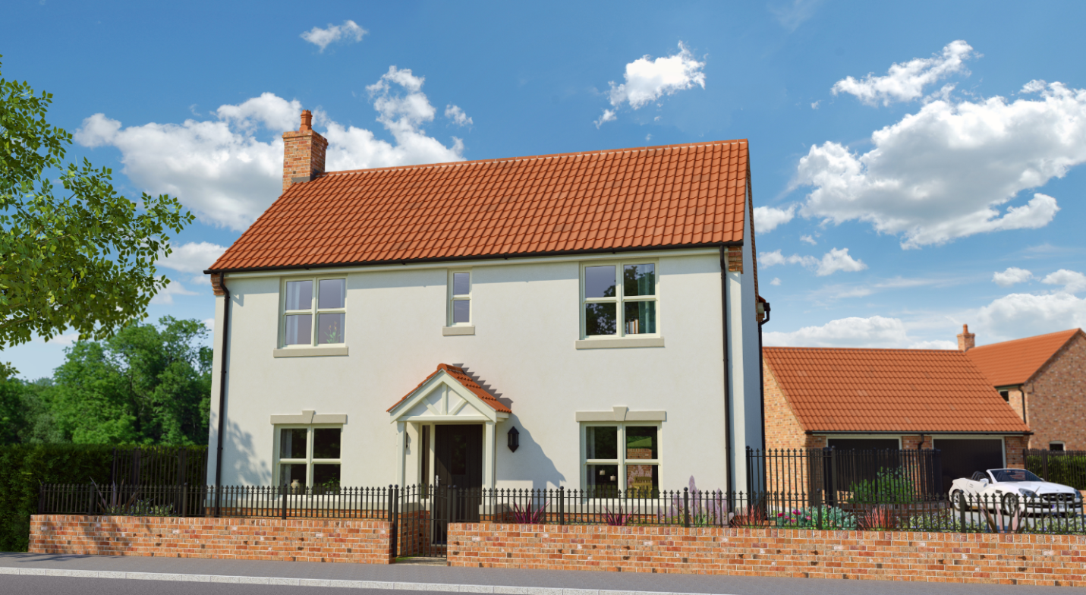

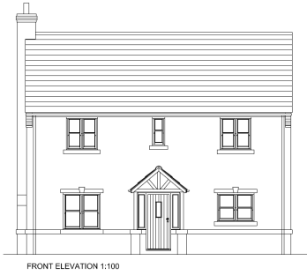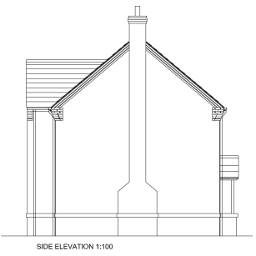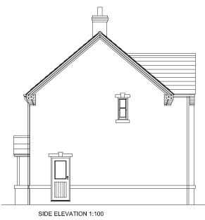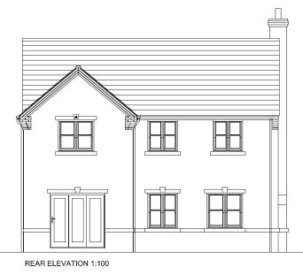
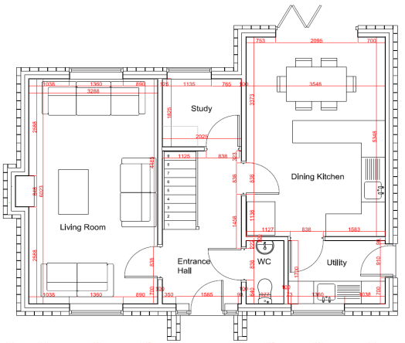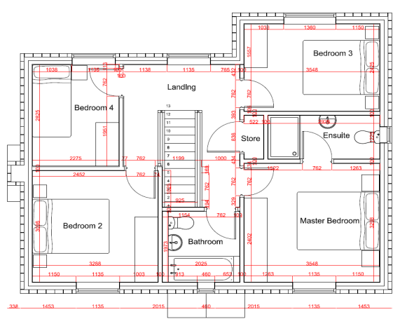

A development of 6 bespoke Architect designed luxury executive dwellings in the beautiful village setting of Walkeringham. A luxury 4 bedroom detached property with detached single garage and private rear garden area. To the first floor of this property it comprises of 4 spaces bedrooms with the master bedroom being en-suite and a large family bathroom and separate storage room. To the ground floor it comprises of large entrance hall, kitchen-diner, utility, study, large living room and downstairs WC.

Ground Floor Measurements: First Floor Measurements:

Living Room - 6023mm x 3288mm Master Bedroom/En-suite - 4523mm x 3548mm
Entrance Hall - 3834mm x 2025mm Bedroom 2 - 3288mm x 3098mm
WC - 1127mm x 2421mm Bathroom - 2025mm x 1973mm
Utility - 2421mm x 1700mm Landing - 3557mm x 3038mm
Kitchen/Diner - 5348mm x 3548mm Bedroom 3 - 3548mm x 2425mm
Study - 2025mm x 1825mm Bedroom 4 - 2825mm x 2275mm

